**Abstract**

In addition to tax breaks, an educate workforce is a significant attractor to draw new businesses and jobs. Tennessee spends more tax revenue on education than any other purpose, but what return do taxpayers see on this investment? Which factors affect how much students improve in terms of their performance on standardized test scores? This paper explores the effects of per-pupil funding, student demographics, levels of education of adults in the community, median home sales prices, and crime rates on student improvement, as measured by proficiency rates and value-added performance on the Tennessee Comprehensive Assessment Program (TCAP). Specifically, this paper seeks to understand which investments county leaders and the business community in Tennessee should make to continue educating future members of the workforce to incentivize increased business development.

**Introduction**

Attracting new businesses to the state requires more than tax breaks. An educated workforce is a significant draw (and the lack thereof a significant deterrent) in luring new jobs and company headquarters to the state (citation needed).

**Research Questions**

This study aims to answer the following research questions:

* What is the relationship between per-pupil funding and students’ test scores on state standardized tests (TCAP) in Tennessee?
* How does per-pupil funding relate to improvements in performance on TCAP?
* What is the relationship between student demographics and district size and TCAP results?
* How do student demographics relate to improvements in performance on TCAP?
* To what degree are county-level factors (e.g., crime rates, housing prices, higher education attainment levels) related to TCAP performance and improvement in TCAP performance?

**Data and Methods**

The present study uses administrative datasets from the 2015 through 2018 to answer the research questions above. We gathered district-level data on test scores, value-added performance,[1] school and district size, student demographics, and per-pupil funding from publicly available data provided by the Tennessee Department of Education. We also collected county-level crime rate information from publicly available data published by the Tennessee Bureau of Investigation. We included median home sales prices and numbers of homes sold from county-level data collected from the Tennessee Housing Development Authority. Finally, our dataset included educational attainment information (i.e., the percent of county residents with a bachelor’s degree) from data published by the Tennessee Higher Education Commission.

While many districts are county-level educational agencies, Tennessee has 50 municipal districts that encompass part of one or more counties. In these instances, we have included county-level data for the county in which the greatest proportion of the district’s students reside for the purposes of our analysis. Because THEC and TBI do not disaggregate data along district and school zone boundaries, this duplication and overlap of data represents a potential threat to the overall quality of the data used in this analysis.

The two outcome variables of interest in this study are districts’ proficiency rates on the Tennessee Comprehensive Assessment Program (TCAP) and their composite TVAAS levels, which range from 1 through 5. To answer our research questions, we consider the following county-level predictor variables:

* Average daily membership[2]
* Number of schools in the district
* Amount of per-pupil funding
* Proportion of students in the district identified as economically disadvantaged[3]
* Proportion of students in the district identified as having a disability
* Proportion of county residents with a bachelor’s degree
* Crime rate per 1000 residents
* Median home sale price

The models and results presented here use the natural logarithm of each variable mentioned, with the exception of value-added composite scores.

**Methods and Results**

We employed both ordinary least squares regressions, as well as fixed-effects models that account for unobserved variation between districts. The results differ slightly between models, as we will explain below.

*Model 1: OLS with TCAP Proficiency Rates*

We first ran an OLS model to examine the effects of county-level funding and demographics on TCAP performance, as described below.

*proficiency_rate = β0 + β1adm + β2number_of_schools + β3per_pupil_funding + β4pct_swd + β5pct_ed + β6pct_with_bachelors + β7crime_rate + β8median_home_sale_price + ε*

where:

* *adm* represents the log of average daily membership
* *number_of_schools* is the log of the number of schools in a given district
* *per_pupil_funding* is the logged value of per-pupil expenditures
* *pct_swd* is the logged proportion of students in the district with a disability
* *pct_ed* is the logged proportion of students in the district who are economically disadvantaged
* *pct_with_bachelors* represents the logged proportion of county adults (ages 25-64) with bachelor’s degrees
* *crime_rate* is the log of the crime rate per 1000 residents, and
* *median_home_sale_price* is the log of the median home sale price for the county in a given year

The table below lists the coefficients, standard error, t values, and alpha levels for each of the predictor variables outlined above.

Coefficients:

Estimate Std. Error t value Pr(>|t|)

(Intercept) 7.91725 1.46011 5.422 8.95e-08 ***

adm 0.23332 0.06761 3.451 0.000603 ***

number_of_schools -0.31667 0.06708 -4.721 3.01e-06 ***

per_pupil_funding -0.76469 0.15443 -4.952 9.91e-07 ***

pct_swd -0.02493 0.07142 -0.349 0.727135

pct_ed 0.10238 0.02347 4.361 1.55e-05 ***

pct_with_bachelors 0.38358 0.05184 7.400 5.39e-13 ***

crime_rate -0.07285 0.04574 -1.593 0.111798

median_home_sale_price 0.03368 0.06951 0.485 0.628187

---

Signif. codes: 0 ‘***’ 0.001 ‘**’ 0.01 ‘*’ 0.05 ‘.’ 0.1 ‘ ’ 1

This OLS model is significant (F8, 530 = 21.95, p < 0.0001) and explains 33 percent of the variation in the data, as shown in the output below.

Residual standard error: 0.3348 on 530 degrees of freedom

Multiple R-squared: 0.2489, Adjusted R-squared: 0.2375

F-statistic: 21.95 on 8 and 530 DF, p-value: < 2.2e-16

*Model 2: OLS with TVAAS Composites*

We also regressed these same predictor variables on districts’ overall TVAAS composites. Recall that these value-added composites are measures of statistical certainty that students made more academic growth than was expected based on their prior testing histories. It is worth noting that value-added estimates are uncorrelated with student poverty.

Coefficients:

Estimate Std. Error t value Pr(>|t|)

(Intercept) -3.8908 7.2788 -0.535 0.593193

adm 1.1168 0.3370 3.314 0.000984 ***

number_of_schools -1.3753 0.3344 -4.113 4.53e-05 ***

per_pupil_funding 0.8296 0.7699 1.078 0.281709

pct_swd -0.4020 0.3560 -1.129 0.259347

pct_ed -0.2085 0.1170 -1.782 0.075376 .

pct_with_bachelors 0.7353 0.2584 2.845 0.004610 **

crime_rate -0.3592 0.2280 -1.575 0.115747

median_home_sale_price -0.4948 0.3465 -1.428 0.153875

---

Signif. codes: 0 ‘***’ 0.001 ‘**’ 0.01 ‘*’ 0.05 ‘.’ 0.1 ‘ ’ 1

This OLS model is still significant (F8, 530 = 6.493, p < 0.0001), though it explains less of the variance in the data (R2 = 0.08926) and some of the coefficient estimates are no longer significant (e.g., per-pupil funding and percent of economically disadvantaged students).

Residual standard error: 1.669 on 530 degrees of freedom

Multiple R-squared: 0.08926, Adjusted R-squared: 0.07551

F-statistic: 6.493 on 8 and 530 DF, p-value: 4.404e-08

*Model 3: Fixed-Effects Model with TCAP Proficiency Rates*

We also ran fixed-effects models to account for any between-district variation that was not adequately captured in the OLS models. These models still revealed significant effects of per-pupil funding and the percent of students who are economically disadvantaged, though some other minor differences emerged. These models also explained roughly the same proportion of the variance in the data (R2 = 0.31612).

Coefficients:

Estimate Std. Error t-value Pr(>|t|)

adm 0.521712 0.402035 1.2977 0.195159

number_of_schools 0.302379 0.257663 1.1735 0.241289

per_pupil_funding -0.965893 0.317513 -3.0421 0.002507 **

pct_swd 0.069774 0.093186 0.7488 0.454450

pct_ed 0.231205 0.024215 9.5479 < 2.2e-16 ***

crime_rate 0.188341 0.134745 1.3978 0.162975

median_home_sale_price -0.516573 0.202843 -2.5467 0.011256 *

---

Signif. codes: 0 ‘***’ 0.001 ‘**’ 0.01 ‘*’ 0.05 ‘.’ 0.1 ‘ ’ 1

Total Sum of Squares: 37.985

Residual Sum of Squares: 25.978

R-Squared: 0.31612

Adj. R-Squared: 0.063793

F-statistic: 25.9514 on 7 and 393 DF, p-value: < 2.22e-16

*Model 4: Fixed-Effects Model with TVAAS Composites*

We also ran another fixed-effects model regressing on value-added performance. This model explains very little of the variation.

Coefficients:

Estimate Std. Error t-value Pr(>|t|)

adm -4.92903 2.32476 -2.1202 0.03461 *

number_of_schools 0.97698 1.48994 0.6557 0.51239

per_pupil_funding 3.69472 1.83602 2.0124 0.04486 *

pct_swd -0.64233 0.53885 -1.1920 0.23396

pct_ed -0.26426 0.14002 -1.8872 0.05986 .

crime_rate -0.35371 0.77916 -0.4540 0.65011

median_home_sale_price -1.25752 1.17294 -1.0721 0.28433

---

Signif. codes: 0 ‘***’ 0.001 ‘**’ 0.01 ‘*’ 0.05 ‘.’ 0.1 ‘ ’ 1

Interestingly between model 3 and model 4, per-pupil funding was a significant predictor of academic performance in both instances, but its impact had an opposite effect on TCAP and value-added performance (i.e., while increases in per-pupil funding are associated with higher levels of academic improvement, increases in per-pupil funding also appear to have a negative relationship with academic proficiency rates).

Additionally, the fixed-effects model looking at the outcome variable of value-added performance explains very little of the variation in the data, which should give us pause in interpreting the results.

Total Sum of Squares: 907.33

Residual Sum of Squares: 868.62

R-Squared: 0.042669

Adj. R-Squared: -0.31054

F-statistic: 2.50234 on 7 and 393 DF, p-value: 0.015879

*Model Specification Tests*

We plotted the residuals of each model described above to confirm that the residuals are evenly distributed around a mean of 0. As shown in the plot of residuals from model 1, there are some concerns that the variation is heteroskedastic.

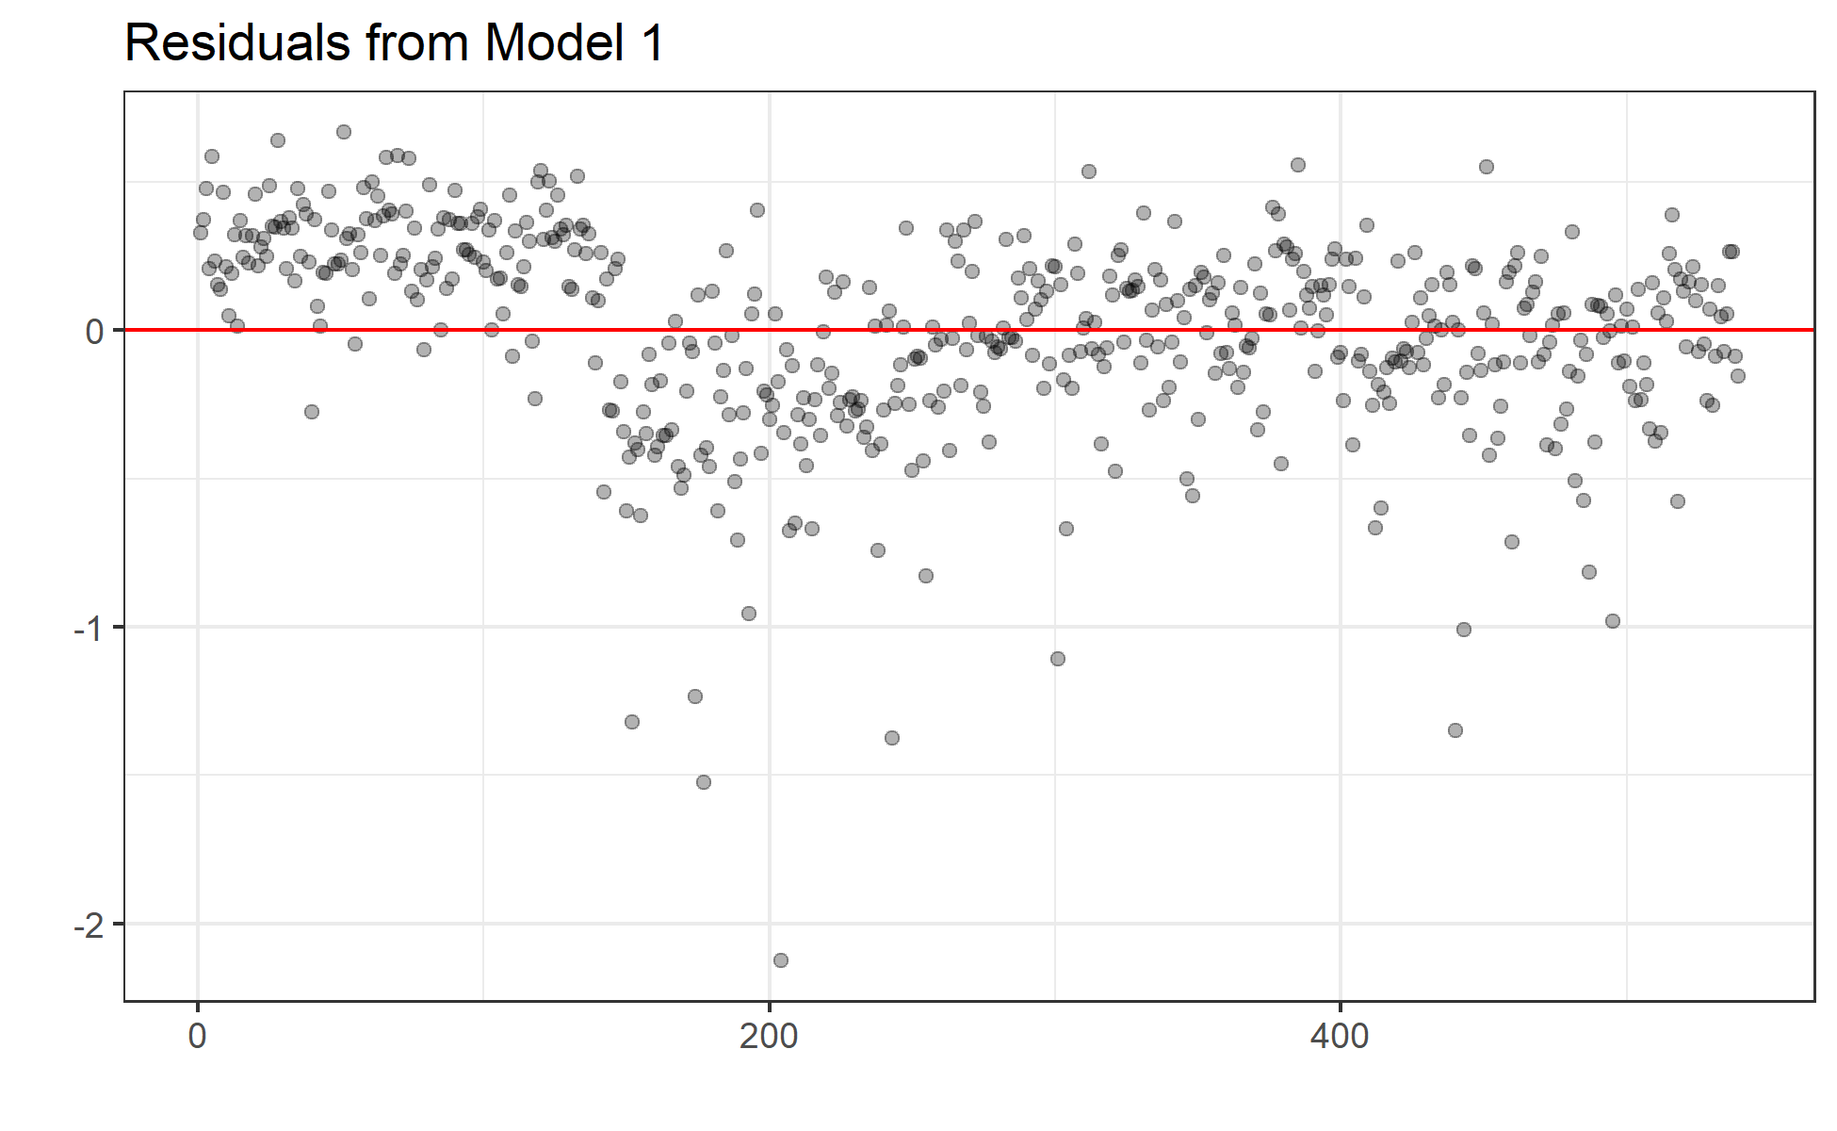

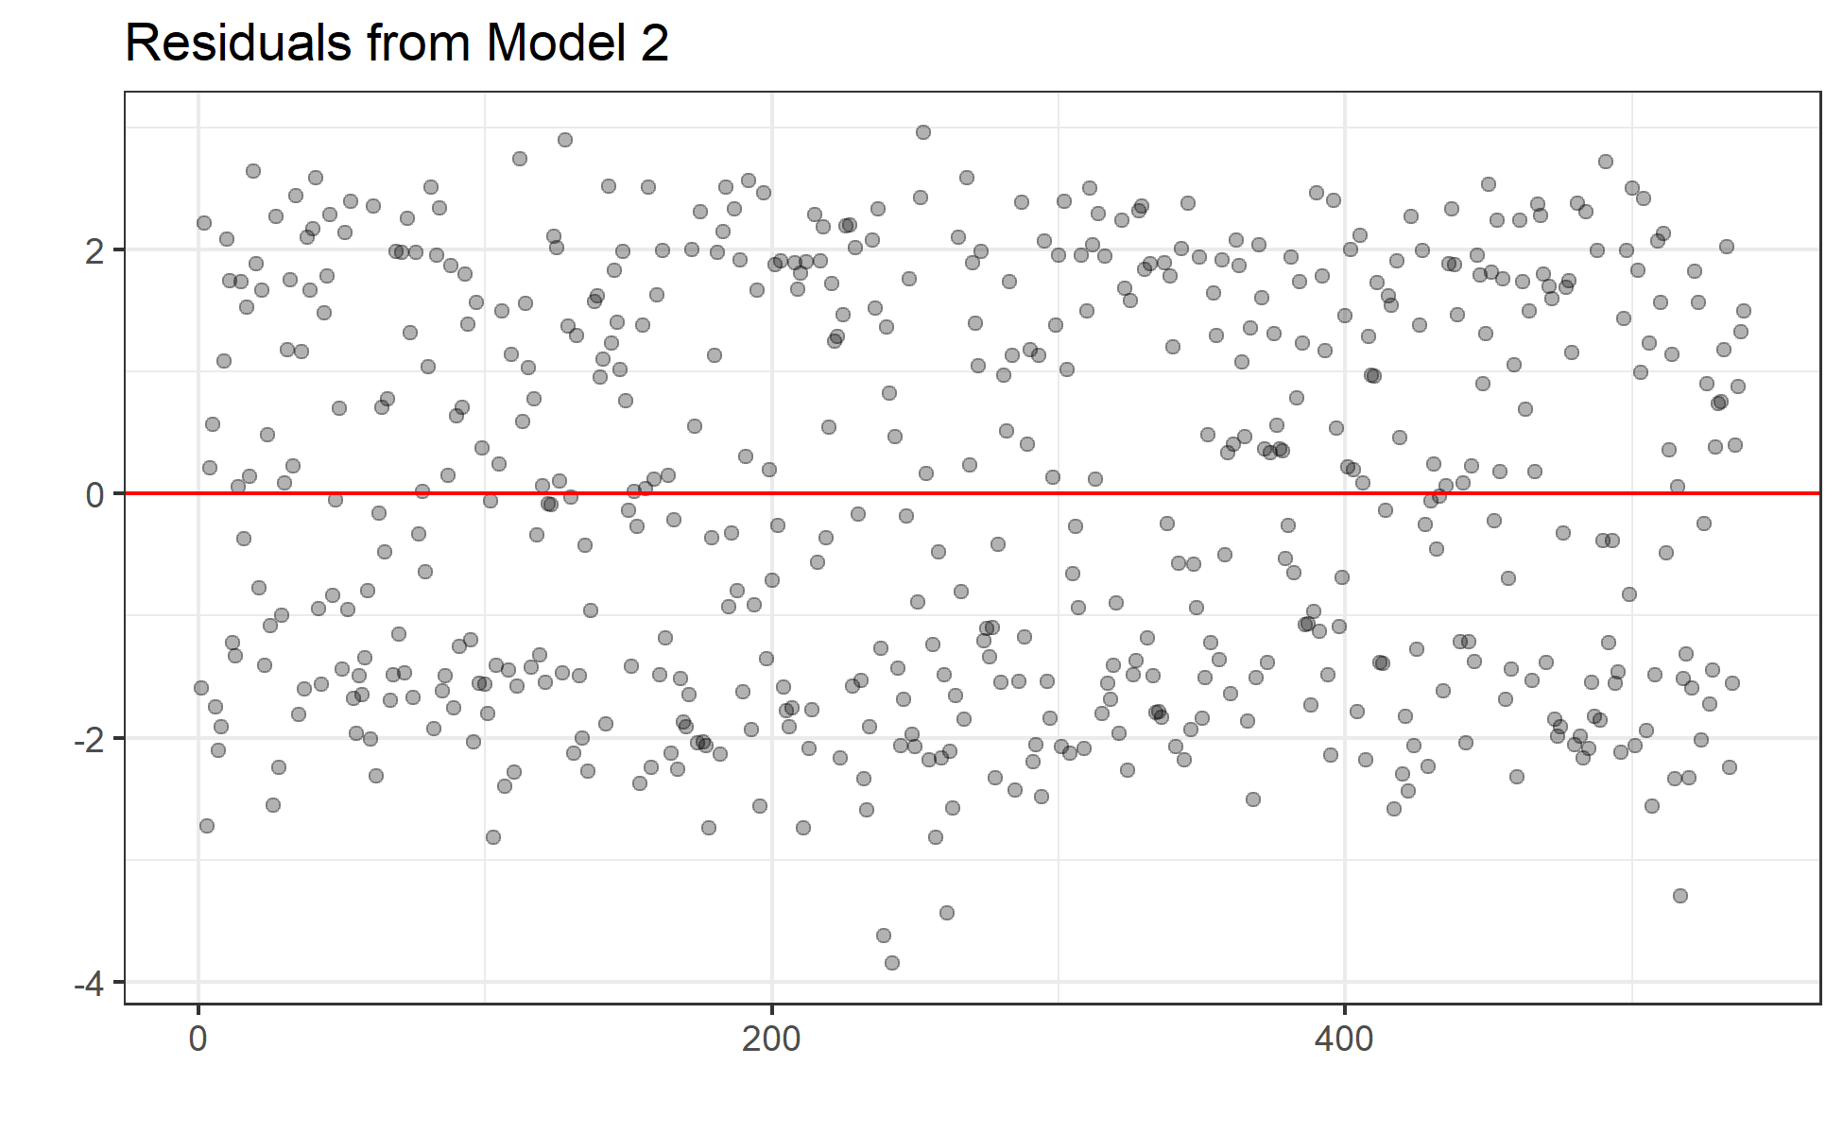

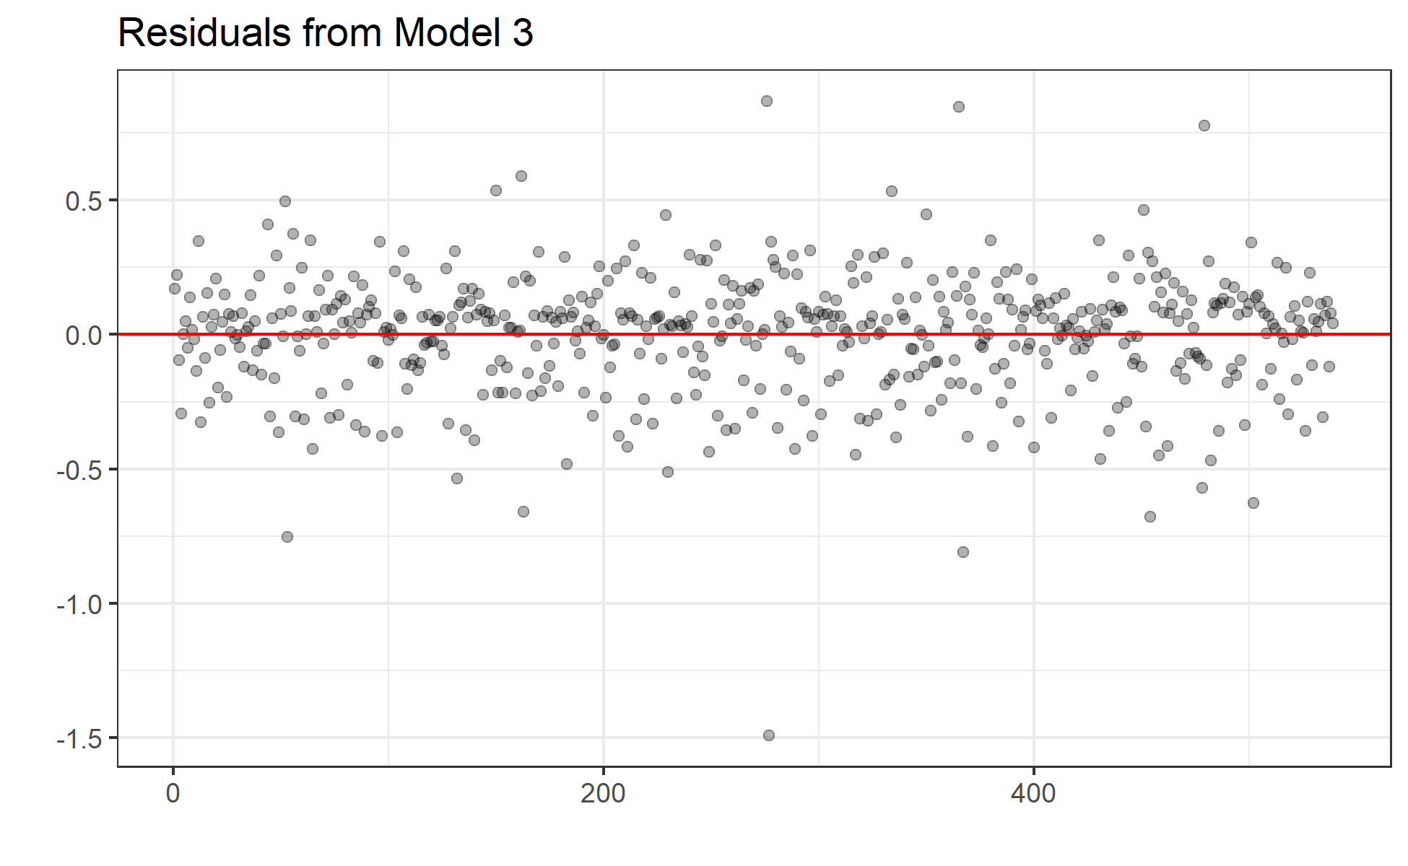

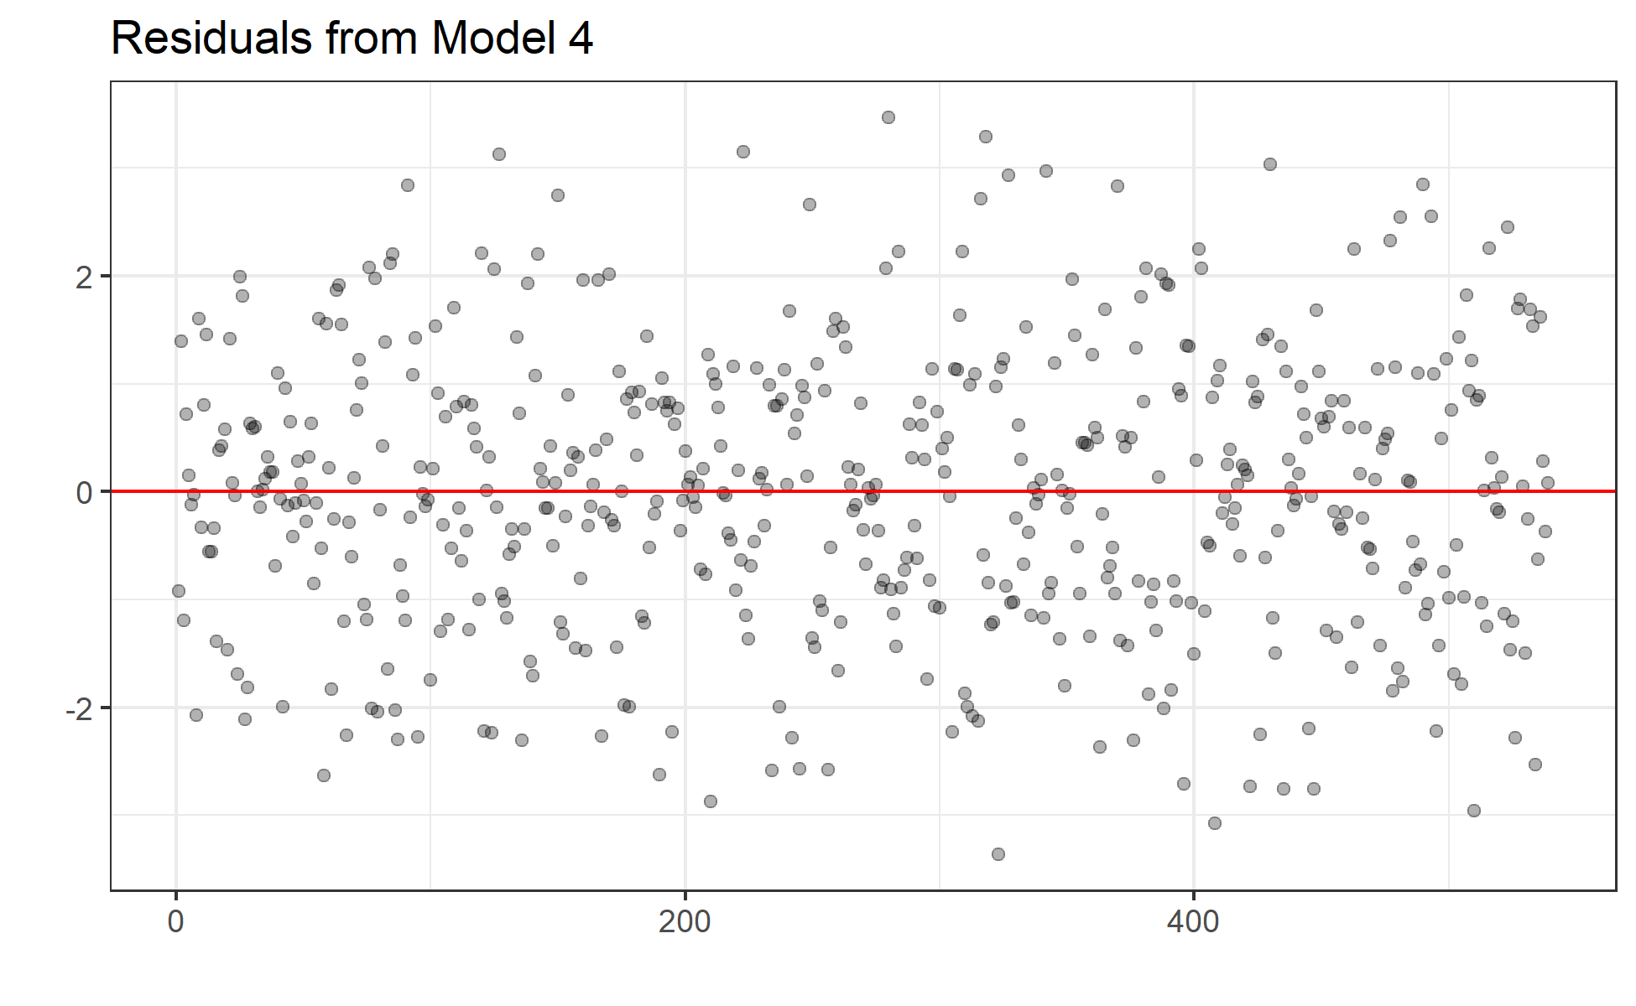

*Relationship between Per-Pupil Funding and Academic Performance*

Our first research question aims to understand the relationship between per-pupil funding and proficiency rates. As we can see from the estimates of the coefficients below, under models 1 and 3, a 10 percent decrease in per-pupil funding would be associated with a decrease in proficiency rates of between 7.6 and 9.6 percent. However, we see this result flipped in the fixed-effects model 4, in which a 10% increase in per-pupil expenditures is associated with a 37 percent increase in proficiency rates.

Coefficients:

Estimate Std. Error t value Pr(>|t|)

per_pupil_funding (1) -0.76469 0.15443 -4.952 9.91e-07 ***

per_pupil_funding (2) 0.8296 0.7699 1.078 0.281709

per_pupil_funding (3) -0.965893 0.317513 -3.0421 0.002507 **

per_pupil_funding (4) 3.69472 1.83602 2.0124 0.04486 *

This is a counterintuitive conclusion. One would assume that spending more money per student would lead to an increase in performance. However, it could also be the case that lower operating costs simply reflect better economies of scale, rather than better service delivery.

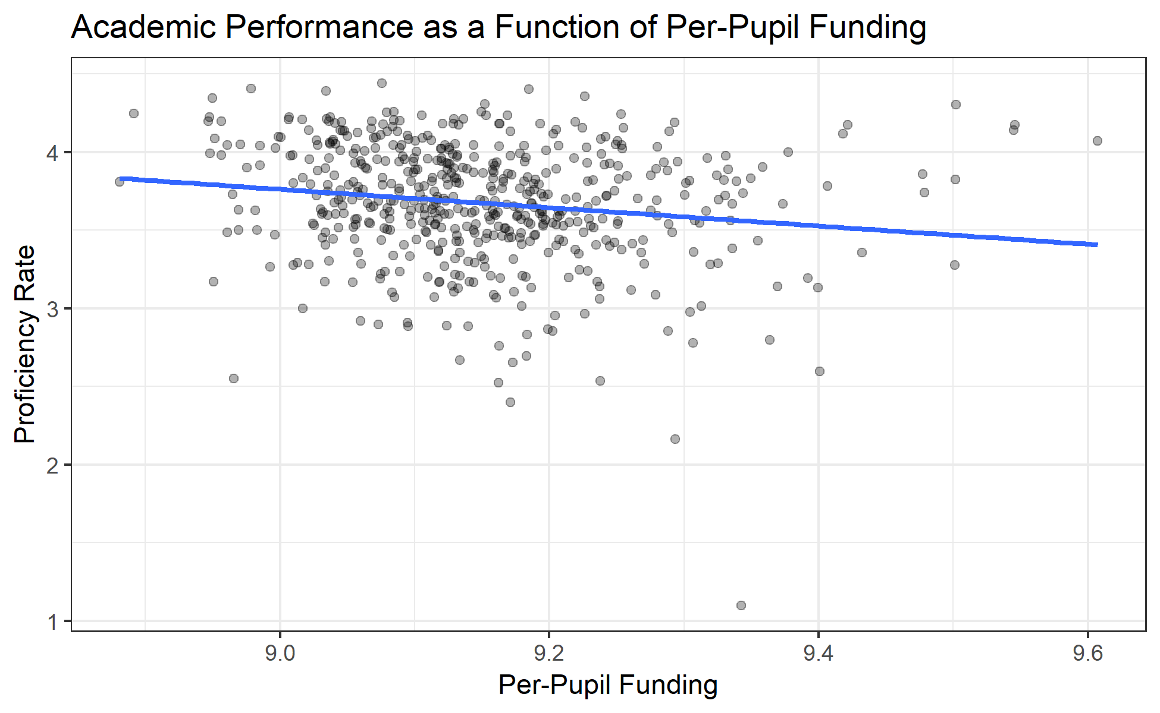

*Student Demographics, District Size, and Academic Performance*

Average daily membership, as a proxy for the size of a school district, also appears to be associated with improvements in academic performance. Based on the different models we ran, we saw observed that a 10 percent increase in district average daily membership corresponds to between 2 percent and 11 percent increase in proficiency rates. However, the fourth model we ran indicated that a 10 percent increase in average daily membership was associated with a 49 percent decrease in proficiency rates.

Coefficients:

Estimate Std. Error t value Pr(>|t|)

adm (1) 0.23332 0.06761 3.451 0.000603 ***

adm (2) 1.1168 0.3370 3.314 0.000984 ***

adm (3) 0.521712 0.402035 1.2977 0.195159

adm (4) -4.92903 2.32476 -2.1202 0.03461 *

Similarly, student demographics, specifically the relative proportion of students in poverty, has different effects on proficiency rates and academic improvement in the different models we used. For example, in the fixed-effects models, the effects of levels of student poverty appear only to be marginally significant and to suggest a negative relationship such that increases in economic disadvantage are associated with lower levels of proficiency. However, the two OLS models suggest that a 10 percent increase in the percent of students who are economically disadvantaged increases proficiency rates by 1-3 percent. This again seems counterintuitive.

Coefficients:

Estimate Std. Error t value Pr(>|t|)

pct_ed (1) 0.10238 0.02347 4.361 1.55e-05 ***

pct_ed (2) -0.2085 0.1170 -1.782 0.075376 .

pct_ed (3) 0.231205 0.024215 9.5479 < 2.2e-16 ***

pct_ed (4) -0.26426 0.14002 -1.8872 0.05986 .

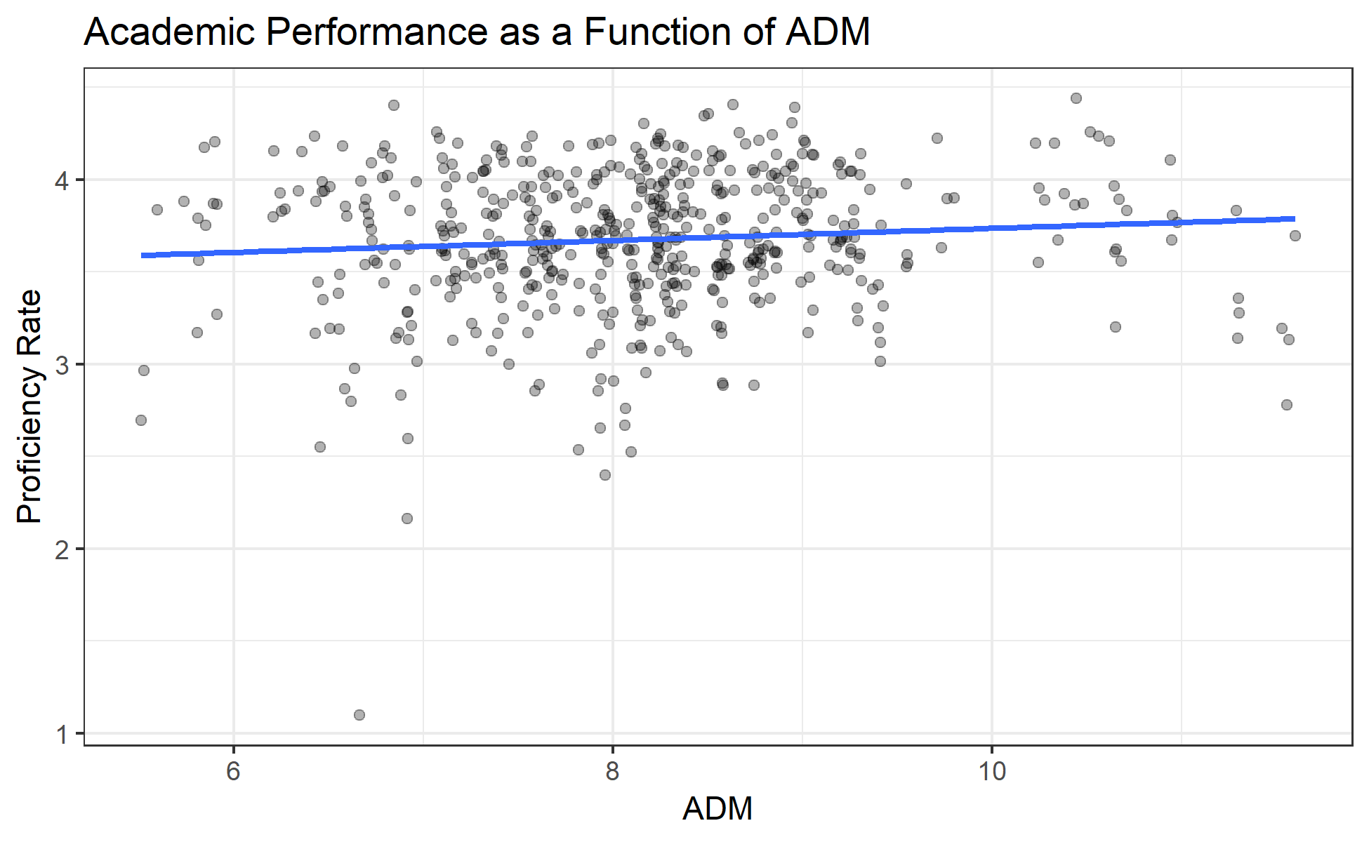

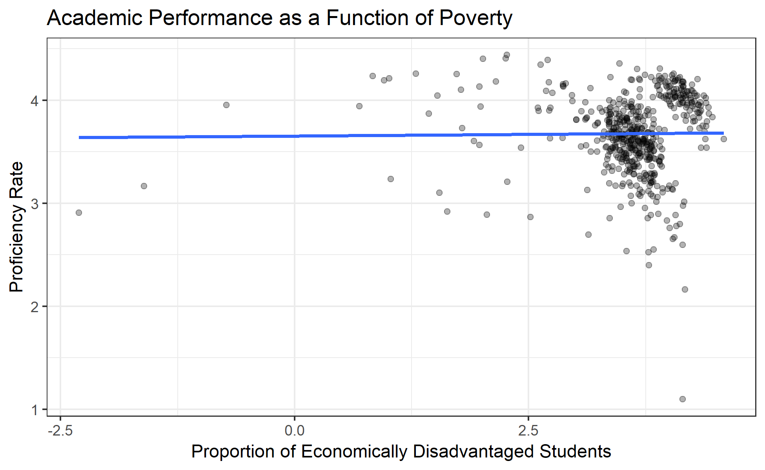

*County-Level Factors*

Interestingly, across all four models, county-level factors such as crime rates and median home prices appeared not to have a significant influence either on proficiency rates or academic improvement. As the table below illustrates, only the fixed-effects model in which proficiency rates served as the outcome variable resulted in a significant coefficient. Given the lack of significant t-values in other models, it is tempting to conclude that this significant coefficient estimate is a statistical outlier. This broad lack of significant results suggests that county officials hoping to improve education in their county should more on reducing poverty than on catching and prosecuting criminals if they hope to improve educational outcomes and improve the attractiveness of their business climate.

Coefficients:

Estimate Std. Error t-value Pr(>|t|)

crime_rate (1) -0.07285 0.04574 -1.593 0.111798

crime_rate (2) -0.3592 0.2280 -1.575 0.115747

crime_rate (3) 0.188341 0.134745 1.3978 0.162975

crime_rate (4) -0.35371 0.77916 -0.4540 0.65011

median_home_sale_price (1) 0.03368 0.06951 0.485 0.628187

median_home_sale_price (2) -0.4948 0.3465 -1.428 0.153875

median_home_sale_price (3) -0.516573 0.202843 -2.5467 0.011256 *

median_home_sale_price (4) -1.25752 1.17294 -1.0721 0.28433

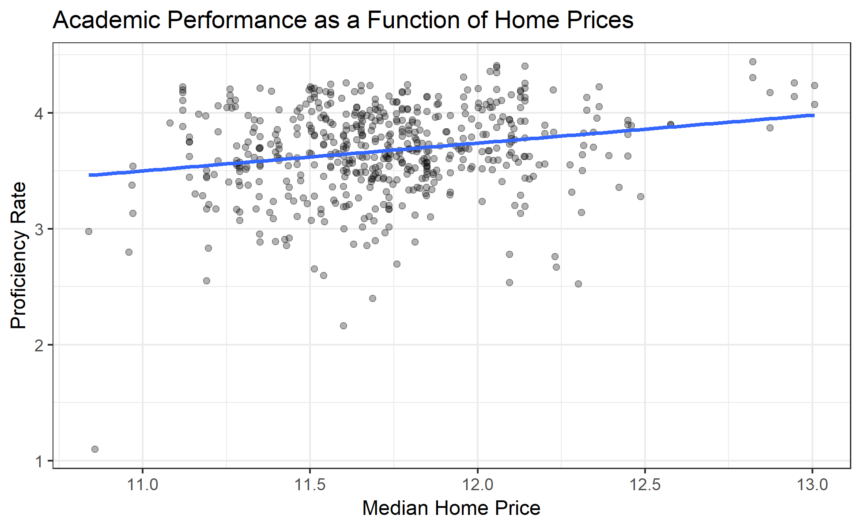

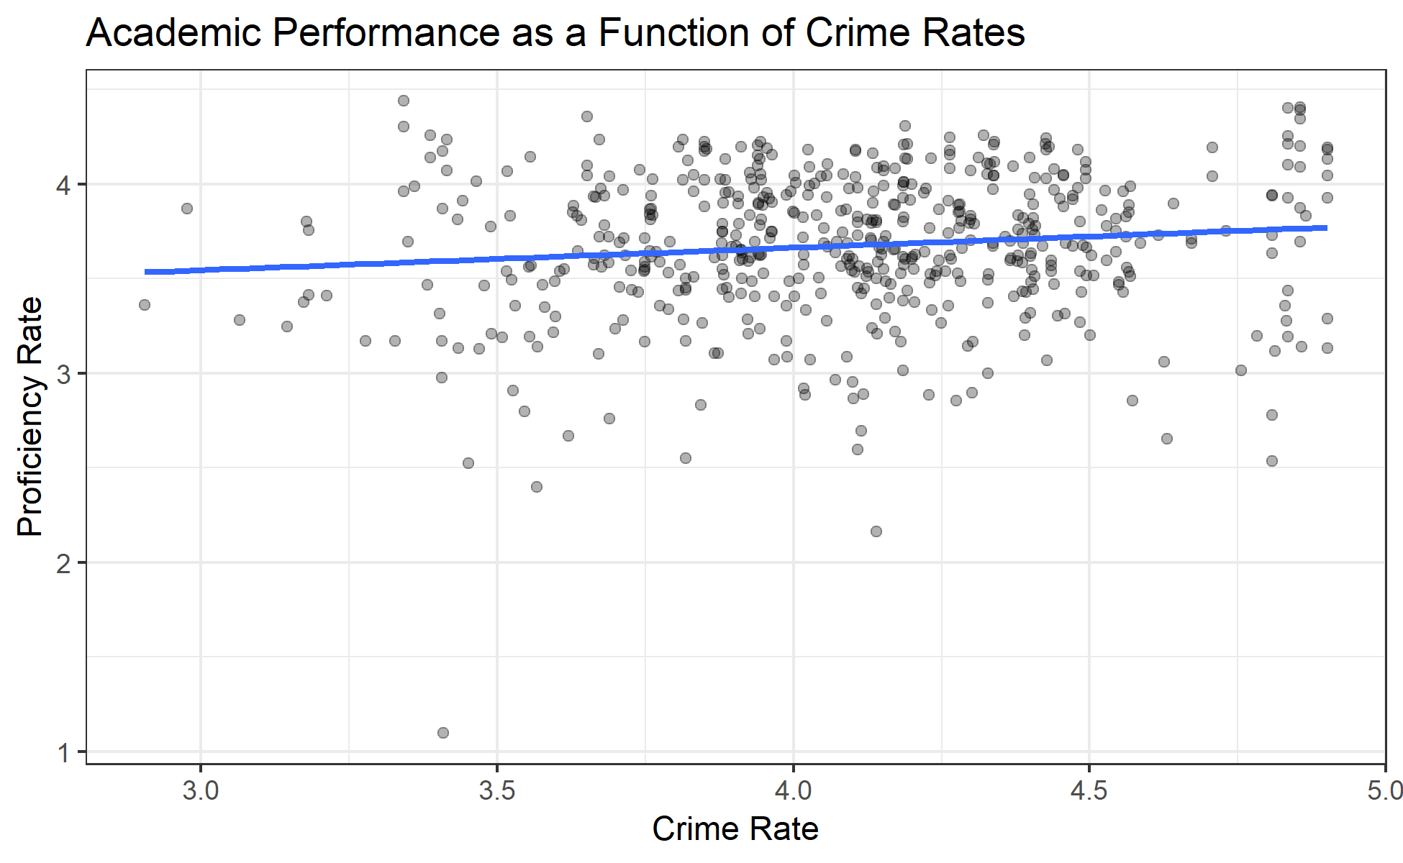

**Conclusions and Limitations**

* Spend money on poverty reduction rather than crime reduction
* More study needed to determine impact of average daily membership and per-pupil fundings

1. Value-added performance (i.e., Tennessee Value-Added Assessment System or TVAAS) is a statistical measure that compares the average predicted scale scores of students in a given district to their actual scale scores. Predicted scores are constructed based on statewide performance and students’ prior test scores. Please consult this [technical documentation](https://www.tn.gov/content/dam/tn/education/data/tvaas/Statistical_Models_and_Business_Rules.pdf) for more information on TVAAS calculations.
2. The Average daily membership calculation represents the average number of students enrolled across various 20-day enrollment periods. For more information, please consult the Tennessee Department of Education’s [Attendance Manual](https://www.tn.gov/content/dam/tn/education/reports/331958_membership_attendance_manual.pdf).
3. Until the 2014-15 school year, students were considered economically disadvantaged based on whether they qualified for free or reduced price lunch. Starting in the 2015-16 school year, students are considered economically disadvantaged through direct certification, that is, if they qualify for other state or federal benefits such as the Supplemental Nutrition Assistance Program.